|  |  |  |  |  |  |
| --- | --- | --- | --- | --- | --- |
| Test scenario | Test case description | Test data | Expected result | Actual result | Pass/ fail |
| Error handling | Cannot open file name | See the image | Display error image |  |  |
| Saving the quote | Saving the quote, information is saved on a new page. | The quote/ all saved information | New page opens with all information saved and presented. | see saved quote, missing date of birth and model make. | Pass |
| Saving the quote | Saving the quote, fresh set of information is saved on a new page. | The quote/ all saved information | New page opens with all information saved and presented. | see saved quote, missing date of birth and model make. | Pass |
| Saving the quote | Cannot save the quote | The quote/ all saved information | Error |  |  |
| Saving the quote | Fresh set of data inputted with different options, saving the quote on a new page. | The quote/ new information | Results in the quote being saved on a new page | see saved quote, missing date of birth, post code and model make. | pass |
|  |  |  |  |  |  |
|  |  |  |  |  |  |

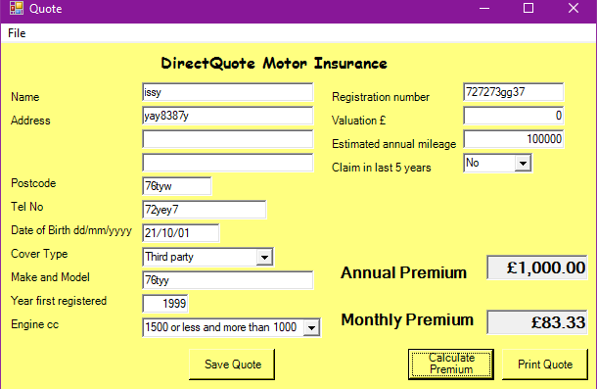First one

Second one.

